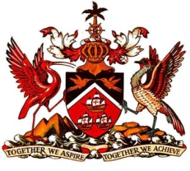

PERMANENT MISSION OF THE REPUBLIC OF TRINIDAD AND TOBAGO
TO THE OFFICE OF THE UNITED NATIONS, GENEVA
Statement by Trinidad and Tobago - Universal Periodic Review of Liberia
Palais des Nations, Geneva, 4TH May, 2015

Thank you Mr. President.

Trinidad and Tobago welcomes the delegation of the Republic of Liberia to the second cycle of their Universal Periodic Review.

Mr. President, it brings great pleasure to note that post-war Liberia is regarded as one of the world’s fastest growing economies. My delegation further notes that this West African nation is rich in natural resources and minerals and also boasts to be the home of Africa’s first female elected head of State. In addition to this, we pay tribute to the fact that as recent as last month, Liberia became the tenth African nation to ratify the Arms Trade Treaty, thus strengthening its legal framework on the illicit transfer of small arms and light weapons.

My delegation wishes to recommend that Liberia consider the following:

1. That a comprehensive prevention strategy together with adequate legislation be introduced to combat the high incidence of sexual and gender based violence;
2. That Liberia continues to improve access to basic health care services especially for antenatal care and patients affected by HIV and the Ebola virus; and
3. That a strategic plan be implemented to ensure that all schools and educational institutions be re-opened in the near future.

I thank you Mr. President.

